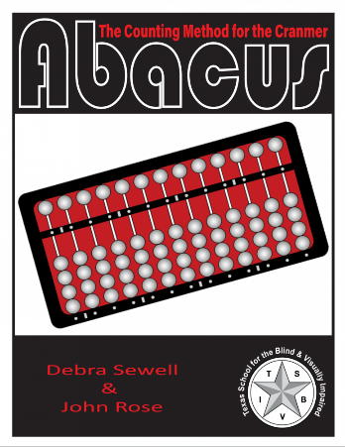
Product #: 59459 ABA TSBVI Online Store
The Counting Method for the Cranmer Abacus
$52.00
Add to Cart
ECC Resources Instructional Strategies Math/Comensatory Book

Product Details
The Counting Method for the Cranmer Abacus is a mathematical tool used for addition, subtraction, multiplication, and division of whole numbers, decimals, and fractions. This publication emphasizes the understanding of place value, outlines the importance of this mathematical tool, and gives step-by-step instructions for completion of sample problems using the counting method.
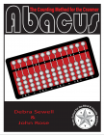
The Counting Method for the Cranmer Abacus
$52.00
Add to Cart

View details at https://www.tsbvi.edu/store/the-counting-method-for-the-cranmer-abacus

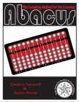
The Counting Method for the Cranmer Abacus Electronic File
$52.00
View Details at https://www.tsbvi.edu/store/the-counting-method-for-the-cranmer-abacus-electronic-file

